**EXPERIMENT:17**

**Demonstrate Storage as a Service (SaaS) create and configure a new VM Image in any Public Cloud Service Provider.**

STEP 1: GO TO THE CREATE AND CLICK THE AZURE VIRTUAL MACHINE.

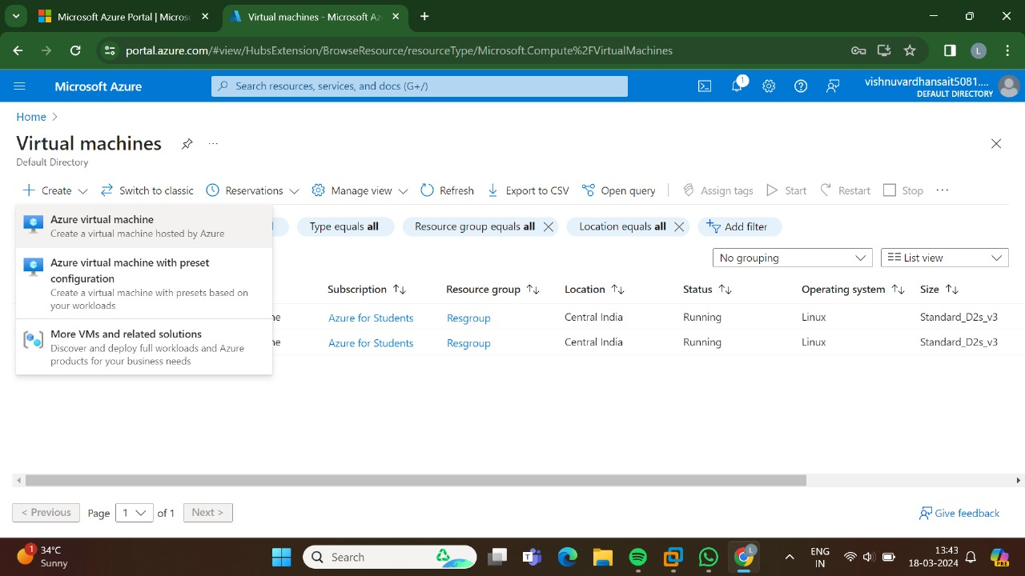

STEP 2: GO TO THE BASICS.

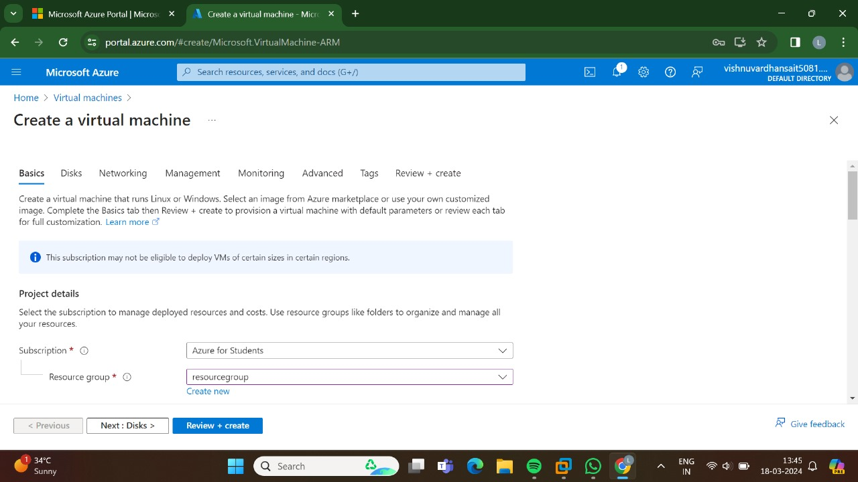

STEP:3:GO TO THE DISKS.

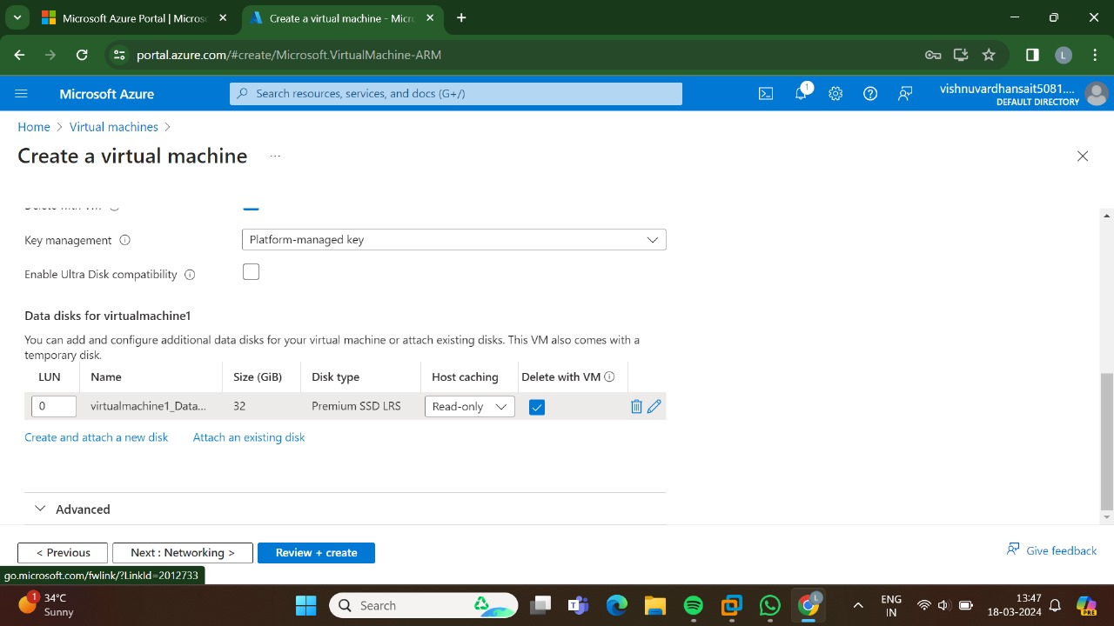

STEP:4:GO TO THE NETWORKING.

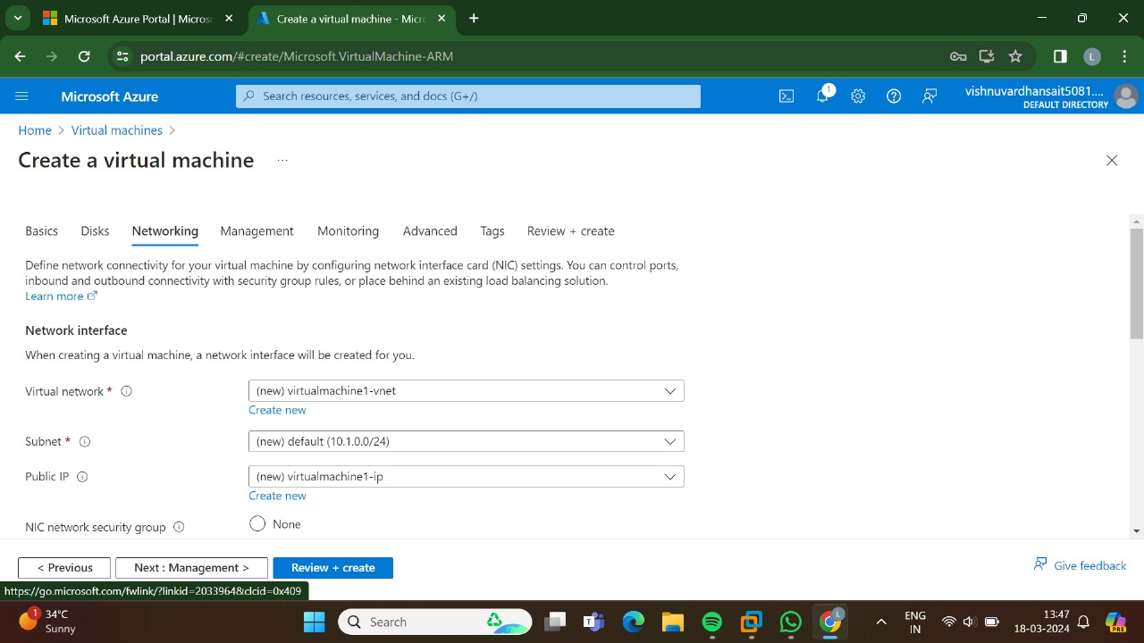

STEP:5:GO TO THE MANAGEMENT.

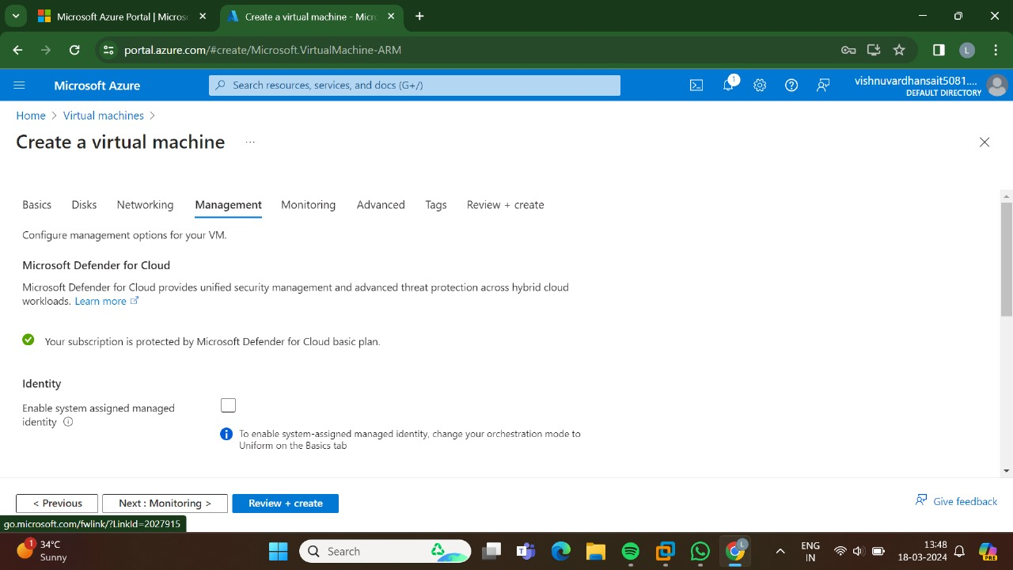

STEP:6:AND, THEN GO FOR THE MONITORING.

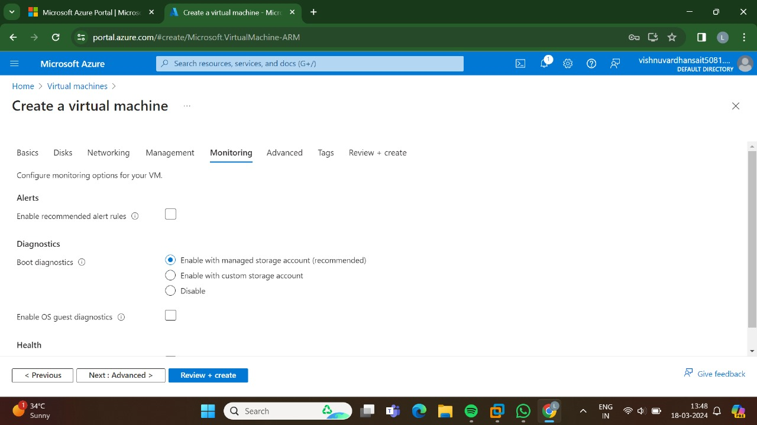

STEP:7:GO FOR THE ADVANCED.

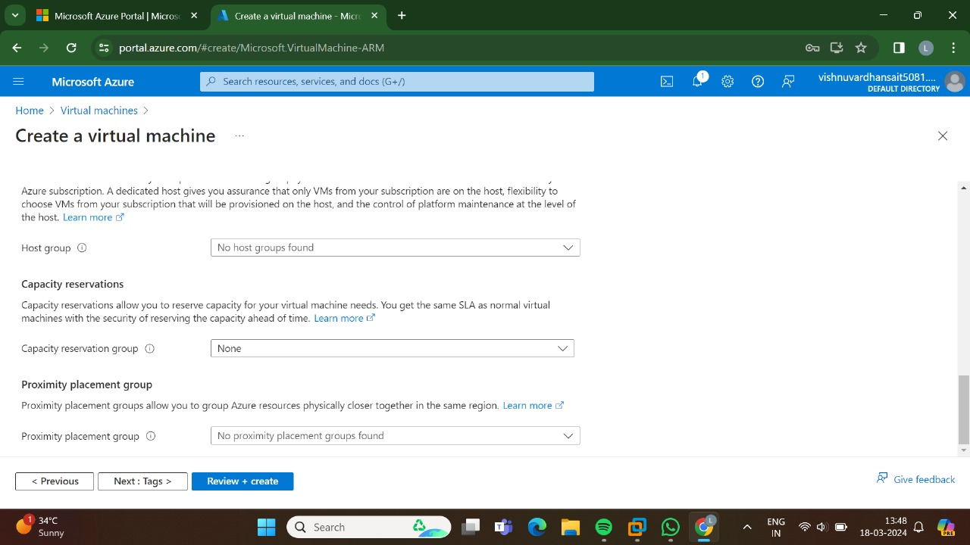

STEP 8: GO, FOR THE TAGS.

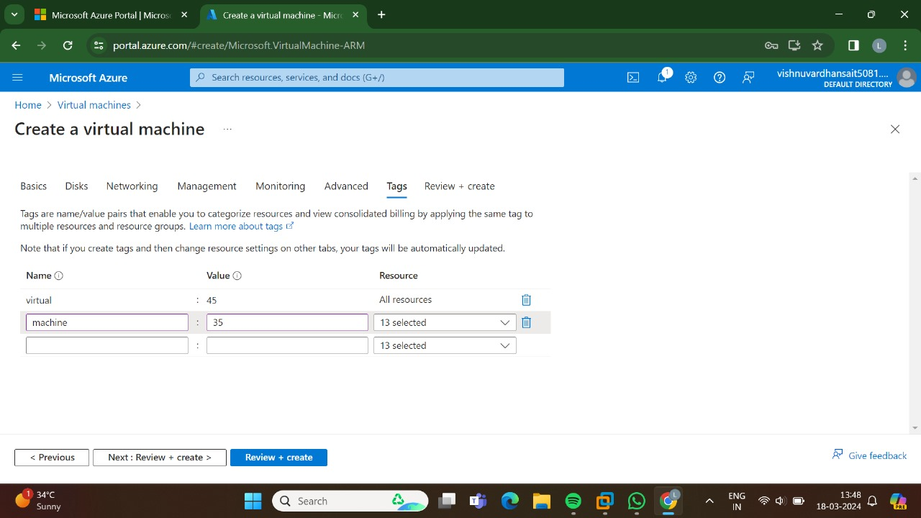

STEP:9:GO FOR THE REVIEW + CREATE AND THEN CLICK CREATE.

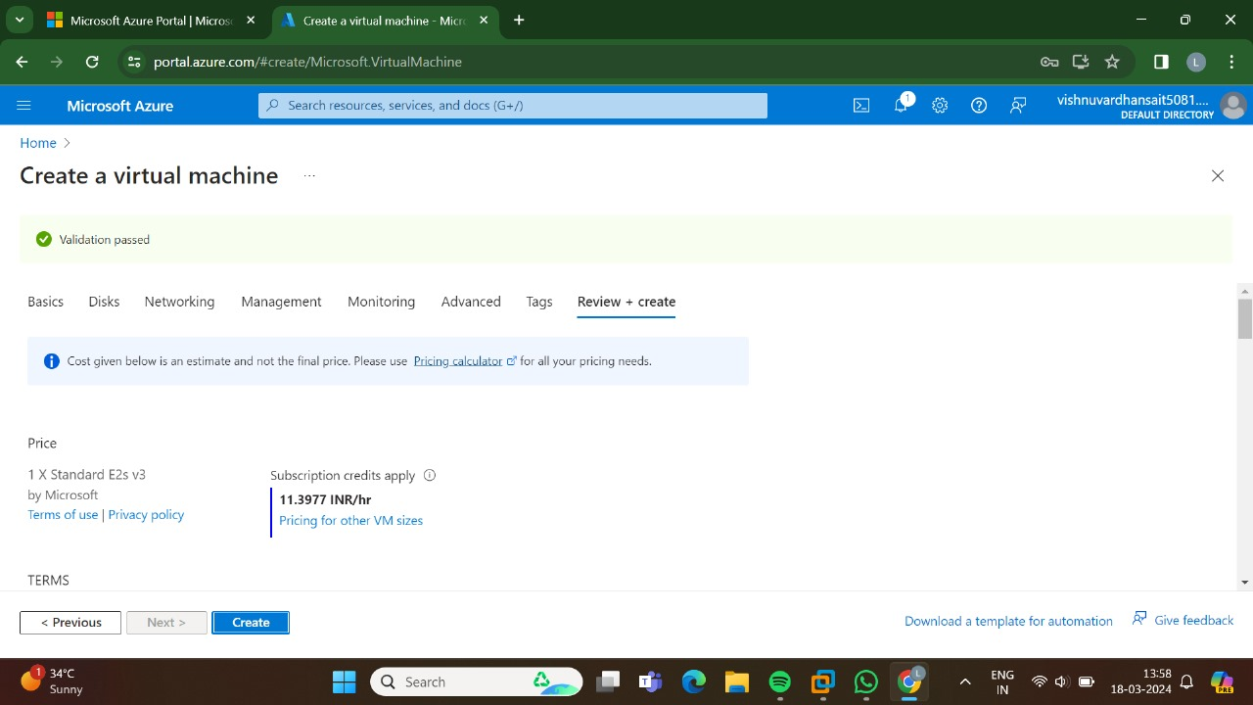

STEP:10:THUS,THE DEPLOYMENT IS IN PROGRESS.

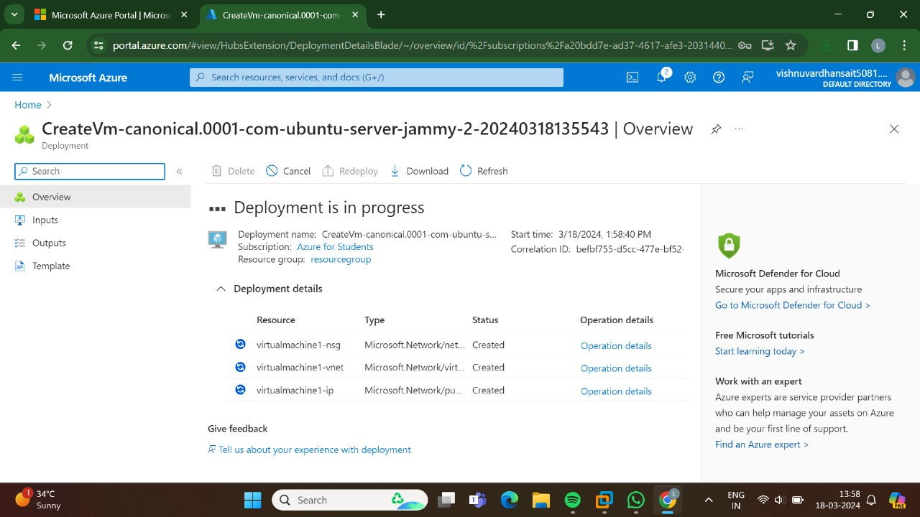

STEP:11:THUS, THE DEPLOYMENT HAS BEEN DONE SUCCESSFULLY.

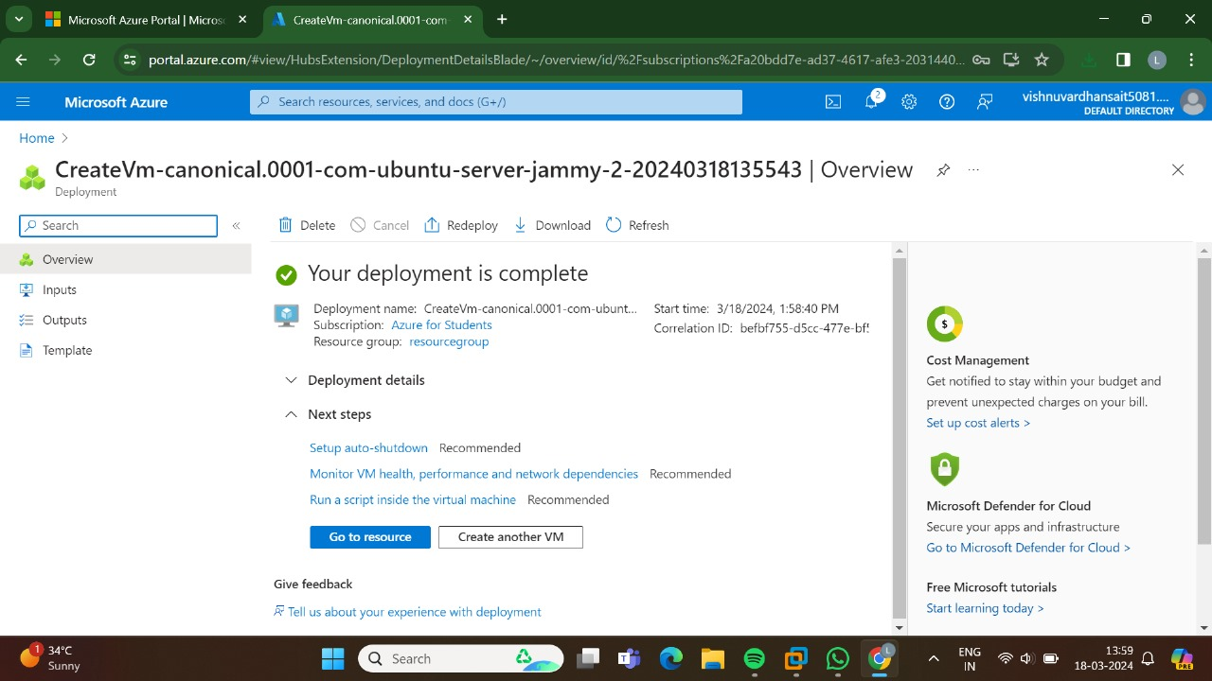

RESULT: THUS, THE PROGRAM HAS BEEN EXECUTED SUCCESSFULLY.